**Page 1:**

What is HTTP and HTTPS?

HTTP is called Hypertext Transfer Protocol. It is an application layer protocol used for transferring data between the entire world wide web. It uses a client-server model which client is the web browser and the host of the web as the server. HTTP is designed for simplicity and made easier to understand. HTTP is not secured, so it is very weak against any form of cyberattacks.

HTTPS is called Hypertext Transfer Protocol Secure. It is the same as HTTP except that it is more secured. It is more secured because unlike HTTP, it uses the transport layer security and secure sockets layer encryption.

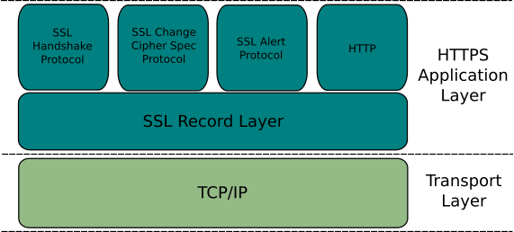

**Page 2:**

How is a web page downloaded?

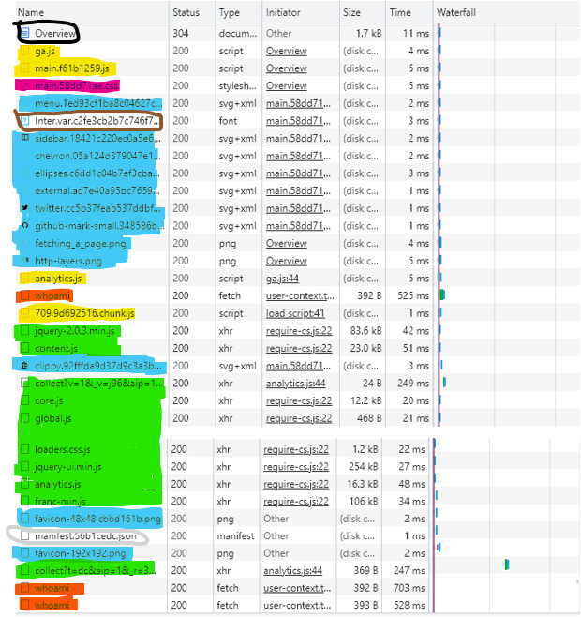

Types of request files

* Images – The blue highlighted ones are all the images.
* Scripts – The yellow highlighted ones are all the JavaScript which the websites use.
* XHR – The green highlighted ones are all the XHR. XHR is called XMLHttpRequest which is used to get or send data to a server and able to update webpages without restarting the whole page.
* Fetch – The orange highlighted ones are fetch requests which are used to get resources from the network. In this case, it is fetching the system user id of the person who went on the site.
* Stylesheet – The violet highlighted one is an external stylesheet. It is used to change how a website looks. The html is linked to the external stylesheet so that it can edit all the elements in the html.
* Documentation – The black boxed one is the documentation file which has all the textual data on the website.
* Font – The brown boxed one is the font file which is used for the fonts on the website.
* Manifest – The grey boxed one is a JSON document. It is a document that contains all the defaults and start up stuff. It also contains meta data.

**Page 3:**

What is a request?

A HTTP request is like a message. It is initiated by the user to the host of the server.

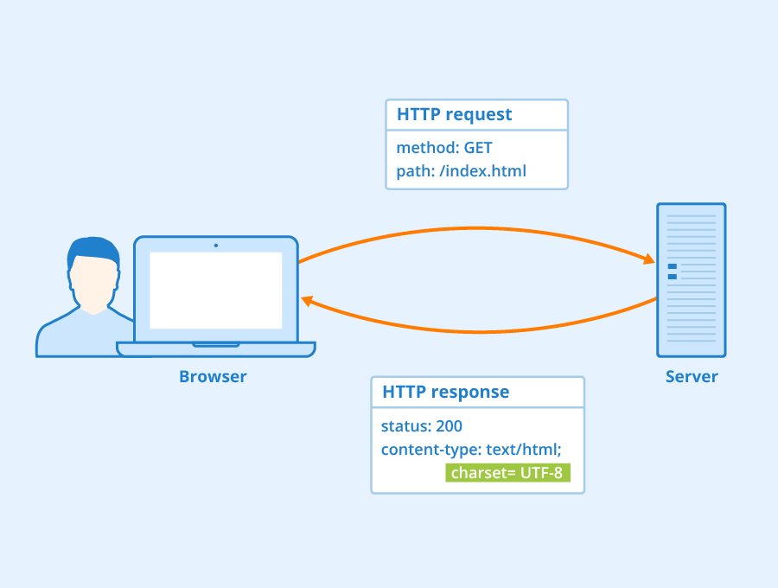

 HTTP Header - Author: Seobility - License: [CC BY-SA 4.0](https://www.seobility.net/en/wiki/Creative_Commons_License_BY-SA_4.0)

HTTP request format:

* Request line
* Request headers
* Empty line after request headers
* Optional body message

Types of requests

|  |  |
| --- | --- |
| Request Type | Description |
| GET | Used for getting data from the server. |
| HEAD | Like GET except only the header and status line information is given. |
| POST | Used for sending data to the server. |
| PUT | Add new item verified by URL to the server. |
| DELETE | Remove item verified by URL from the server. |
| CONNECT | Used to make a two-way connection to server and the client. |
| OPTIONS | Used to describe the options of communication for the resource being used. |
| TRACE | Used to perform a message loop back test which tests the resource path. It is also used for debugging. |

Types of Error Codes

|  |  |
| --- | --- |
| Error code | Description |
| 200 | Ok - This means that the request worked. |
| 301 | Permanent Redirecting – The URL of the resource has been moved permanently so you will be moved the new URL using the response given by the server. |
| 302 | Temporary Redirecting – The URL of the resource has been moved temporarily. |
| 404 | Not Found – This means that the server is not able to find the resource that was requested by the client. |
| 410 | Gone – This means that the resource requested has been deleted from the server forever. |
| 500 | Internal Server Error – This means that the server has an error that it is unable to solve. |
| 503 | Service Unavailable – This means that the server is down or overloaded with requests that it cannot handle the request given by the client. |

**Page 4:**

When to use GET and POST?

GET is used when you want to retrieve something from a resource. POST is used for sending data to the server. You would use GET when you are getting data which doesn’t change anything on the server. An example of GET is searching for items to buy in an online store. You would use POST when you are creating, editing, deleting things on the server. An example of POST is adding items into your cart in an online store.

Example of GET and POST

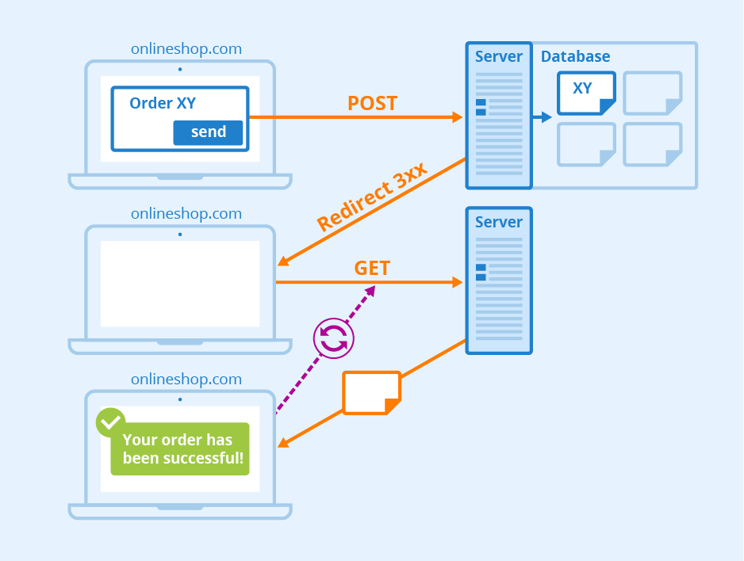

Post/Redirect/Get - Author: Seobility - License: [CC BY-SA 4.0](https://www.seobility.net/en/wiki/Creative_Commons_License_BY-SA_4.0)